**Neha Malhotra**  **R.L. Institute M: 9416974837**

**Max Time : 1 hr** **Class = 12th Biology Test**  **Max Marks : 25**

**BIODIVERSITY AND CONSERVATION**

1. Multiple choice questions : [ 1 X 5 = 5]
2. The historical convention on biological diversity held in Rio de Janeiro in 1992 is known as :

|  |  |  |  |
| --- | --- | --- | --- |
| a) CITES convention | b) The Earth Summit | c) G – 16 Summit | d) MAB programmes |

1. What is the common to the techniques : (i) IVF (ii) cryopreservation (iii) Tissue culture?

|  |  |
| --- | --- |
| a) All are in situ conservation methods | b) All are ex situ conservation methods |
| c) All required ultramodern equipment & large space | d) All are method of conservation of extinct org. |

1. Which of the following forests is also known as the “lungs of the planet Earth”?

|  |  |
| --- | --- |
| a) Taiga forest | b) Tundra forest |
| c) Amazon rain forest | d) Rainforests of North east India |

1. The active chemical drug reserpine is obtained from:

|  |  |  |  |
| --- | --- | --- | --- |
| a) Datura | b) Rauwolfia | c) Atropa | d) Papaver |

1. Which of the following group exhibit more species diversity?

|  |  |  |  |
| --- | --- | --- | --- |
| a) Gymnosperm | b) Algae | c) Bryophytes | d) Fungi |

1. Name the three important components of Biodiversity. [ 1 ]
2. What are sacred groves? Write their role in conservation. [ 1 ]
3. What are seed banks? [ 1 ]
4. Expand IUCN. [ 1 ]
5. What is cryopreservation? Give its one use. [ 1 ]
6. Is it true that there is more solar energy available in the tropics? Explain briefly. [ 1 ]
7. Write any three hypotheses put forth by ecologists explaining the existence of greater biodiversity in tropical regions than in temperate regions. [ 2 ]
8. Differentiate between insitu and exsitu conservation. [ 2 ]
9. Why should be conserve biodiversity. [ 2 ]
10. (a) Explain ‘Rivet popper’ hypothesis. Name the ecologist who proved it. [ 3 ]

(b) What are the major causes of lose of biodiversity. Explain any two.

1. The graph shows species-area relationship: [ 5 ]

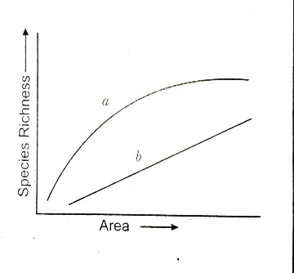

1. If ‘b’ denotes the relationship on log scale.
2. Describe ‘a’ and ‘b’.
3. How is the slope represented? Give the normal range of slope.
4. What kind of slope will be observed for frugivorous birds and mammals in a tropical forest?
5. Species diversity of plants (22 %) is much less than that of animals (72 %). Analyze the reasons for greater diversity of animals as compared to plants.